**CHAPTER 1**

**DHRITVAN**

**COMPANY PROFILE**

**Company Name: DHRITVAN**



**Figure 1 Company Logo**

DHRITVAN is SJCIT’s Satellite Ground Station which has been racing with the leading satellite Ground stations across the world to produce quality output in the form of weather images, telemetry data, denoising algorithms and exploring different areas of space science.

The students working here would get an amazing experience to brainstorm their ideas and covert them into a real-time working environment. Figure 1.1 show the Company Logo of DHRITVAN SPACE LAB

**1.2 ABOUT THE COMPANY:**

DHRITVAN is one of the Amature Satellite Ground Station present across the country and is the first and the only SATELLITE GROUND STATION in chickballapura district,Karanataka. It was established on 27-08-2022 by the Department of Electronics and Communication Engineering at SJC Institute of Technology, Chickballapura-562101.DHRITVAN has been achieving significant results by experimenting various domains in the field of space science and satellite study. The first project taken up by DHRITVAN was to receive satellite signal from open source weather satellite called as NATIONAL OCEANOGRAPHIC ATMOSPHERIC ADMINISTRATION (NOAA) by NASA. Emerging successful with this project DHRITVAN has a strong database of the weather images captured from NOAA satellites on daily basis. As of December 2022 DHRITVAN stands with more than 200 successful times of signal captured from and over 1000 processed weather images. The next challenge to be addressed was to capture signal from a Russian satellite called as METEOR-M2 which emits signal directly in the digital form.

In parallel with signal reception from satellites using omnidirectional antenna DHRITVAN started to work with the antenna design and construction to make it as indigenously constructed satellite ground station. Antenna such as V-dipole, Turnstile, Quadrifilar Helix, etc., are lined up for construction processes. Projects related to antenna design and construction has been proposed as the internship projects for student interns interested to work at DHRITVAN. Some of the future plans at DHRITVAN includes converting it into a transceiving station, development and commercialization of different types of antenna for varied application, design of components such as Low-Noise Amplifiers, noise removal filters, Software Defined Ratios, etc. Since its establishment, DHRIVAN has been making noteworthy records and achievements which has been highly appreciated by the college management, tech – circle and also from the professionals working at the Indian Space Research Organization. The highly enthusiastic team working at DHRITVAN has been working tirelessly in-order to make DHRITVAN commomly called as SPACE LAB a huge success.

DHRITVAN can be reached out through mail at [dhritvan27082022@gmail.com](mailto:dhritvan27082022@gmail.com) and on social media as @dhritvan_sjcit (Instagram and Twitter). Its registered address in opp. To CN Lab, 1st floor, Academic block, SJC Institute of Technology, Chickballapura-562101.

**1.3 COMPANY’S VISION AND MISSION:**

**VISION:** To discover, augment and understand space science for the Nation’s growth and the benefit of mankind.

**MISSION:**

1. Developing pertinent engineering professionals to maneuver in the area of space science, research and exploration.
2. Promoting emerging technologies in space science acumen to venture into innovation research activities.
3. Manifest students to aeronautics, planetary exploration and emerging frontiers in related domains enabling solid and steady establishments.
4. Encourage lifelong learning and experimentation among the student and faculty irrespective of the domain.

CHAPTER 2

FIELD

2.1 Image Processing

Image processing is the manipulation of digital images using computer algorithms to enhance, analyze or reconstruct images. It is a subfield of signal processing and computer vision.

In Image processing there are majorly four steps as following

CLASSIFICATION

FEATURE

EXTRATION

SEGMENTATION

PRE-PROCESSING

**PRE-PROCESSING:**

1.Every image is a combination of some finite number of pixels. Pixels are the functional blocks of image.

2.Each pixel has particular intensity value and based on the number of plane combination, will form the image.

3.Now we can access the value intensity by the storing intensity in form of there indexes means in form of matrix.

4.Preprocessing is the first step in images processing. It happens by performing some matrix operations like matrix’s multiplication, transpose of matrix etc.,

5.In Octave, we have different type of commands to covert one form of image into another form of image like rgb2gray(), rgb2hsv(),etc., planes

**SEGMENTATION:**

It is the next step after preprocessing. Segmentation is used make the masking operation means the foreground and background can be easy get differed. There are two types of segmentation methods.

1. Pixel Based Segmentation
2. Non-Pixel Based Segmentation

**PIXEL BASED SEGMENTATION:**

1.In general, every color image is made of three planes which are red, green and blue which is knowns as RGB image. By converting RGB (3-dimensional) image into gray (2-dimensional) image. It creates different shades of black and white the value is near to 255 then it will be near to white color and similarly if intensity value is near to 0 then it will be near to black color. By considering a various threshold values to make the image obtained near to ground truth to get maximum accurate image formed near to ground truth.

2.Similarly by converting RGB image into HSV(hue, saturation, value)(3-dimensional) image. Now take hue plane and saturation plane in order to create the near to ground truth image by taking two sperate threshold values. Same result will be performed as in above.

**NON – PIXEL BASED SEGMENTATION:**

In non pixel based segmentation methods are those that do not rely on the individual pixels of an image to segment it. Instead, they use other features of the image, such as edges, texture or shape.

**FEATURE EXTRACTION:**

Feature extraction is the process of transforming raw data into a set of features that are relevant to the problem at hand. In image processing, feature extraction is used to extract features from images that can be used for tasks such as object recognition, image classification and image segmentation.

Low-level feature extraction: This type of feature extraction method extracts features from individual pixels or small groups of pixels. Like Intensity, color, texture, edge, shape etc.,

High-level feature extraction: This type of feature extraction method extracts features from larger regions of an image. Like Moments, Wavelets, SIFT(Scale-Invariant Feature Transform),SURF(Speeded Up Robust Features).

CHAPTER 3

**IMAGE PROCESSING AND PATTERN RECOGNITION**

**3.1 Prerequisites:**

The file of p44.mat and ground truth of p44.mat. And data base of 51 image files which can be loaded based on our requirement. Octave open source software with is used to operate with images and this data base have different number of balloons and of different Intensity of images. WHY OCTAVE?. it is very easy to understand and easy to search the commands in documentation.

Getting of Accuracy is a big challenge. But we can get by using of values of true positive (TP), true negative (TN), false positive (FP), false negative (FN).

True Positive (TP): the number of cases correctly identified as balloons [3].

True Negative (TN): the number of cases incorrectly identified as balloons [3].

False Positive (FP): the number of cases correctly identified as balloons [3].

False Negative (FN): the number of cases incorrectly identified as balloons [3].

Accuracy is Measured as

False rate is Measured as

True rate is Measured as

To get image which is near to ground truth. We need to perform morphological operations we can add or remove additional pixels in the image obtained.

1.**Imdilate:** The value of the output pixel is the maximum value of all pixels in the neighbourhood. In a binary image, a pixel is set to 1 if any of the neighbouring pixels have the value 1.

Morphological dilation makes objects more visible and fills in small holes in objects. Lines appear thicker, and filled shapes appear larger.[4]

2.**Imerode**:The value of the output pixel is the *minimum* value of all pixels in the neighbourhood. In a binary image, a pixel is set to 0 if any of the neighbouring pixels have the value 0.

Morphological erosion removes floating pixels and thin lines so that only substantive objects remain. Remaining lines appear thinner and shapes appear smaller.[5 ]

3.**Imopen:** Dilation followed by Erosion is known as Open morphological operation.[5]

4.**Imclose:** Erosion followed by Dilation is known as Close morphological operation.[5]

**3.2 Tasks:**

1.Finding Best single threshold image which should be near to ground truth.

2. What is the need of two thresholds and find that two thresholds image.

3. What is the use of HSV (3-dimensional) image and find their threshold values.

4. Count the number of balloons present in all the images of the data set of 51 images.

**3.3 Solutions of Tasks:**

**TASK-1 Finding Best single threshold image which should be near to ground truth.**

1**.** Take image by loading p44.mat file which is stored as ‘img’ in that file and load ground truth_p44.mat in which the ground truth is stored with the name of A.

2. Now convert the original image which is in RGB plane into grey scale image now by taking the threshold values from 1 to 254 and with the help of the function which is created to get Accuracy, False rate and True rate of a image by with help of the ground truth. By using the above analysis method.

3. At which index of array images the best accuracy will be achieved that image will be known as the best image with single threshold. But one of the disadvantages is because there is the loss of information due using of single threshold as we can observe in below figures.

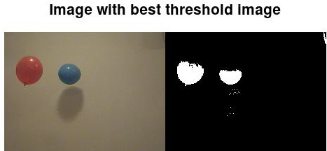

**Figure -2 Image with best threshold**

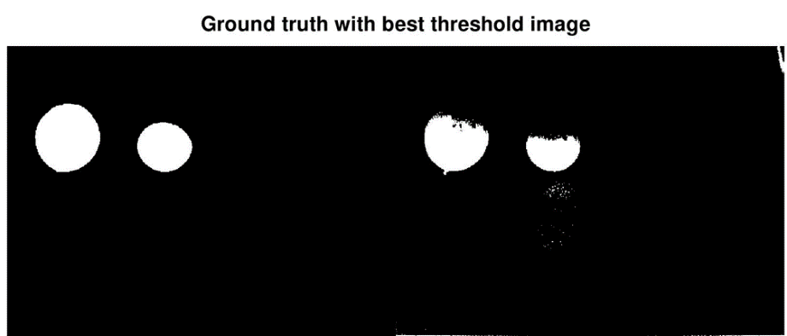

**Figure-3 Ground truth with best threshold**

**ROC (Receiver Operating Characteristic Curve) of single threshold:**

An **ROC curve** (**receiver operating characteristic curve**) is a graph showing the performance of a classification model at all classification threshold.

ROC curve plots TPR vs. FPR at different classification thresholds. Lowering the classification threshold classifies more items as positive, thus increasing both False Positives and True Positives. The following figure shows a typical ROC curve.[5]

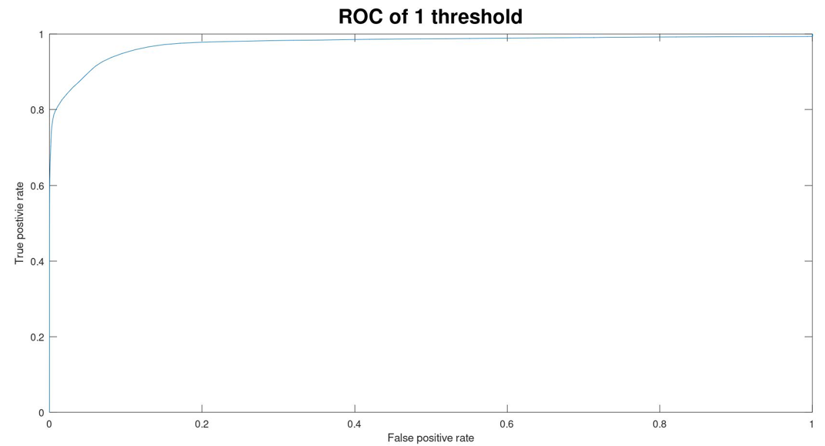

**Figure-4 ROC with Single threshold**

**TASK-2 What is the need of two thresholds and find that two thresholds image**

1.By observing above ROC by single threshold image we are able to understand that there is a loss of information from the original image hence to reduce the loss of information we use two threshold masking method.

2. With the same threshold values for but find the index of the image in both planes red and green by using the method of accuracy. Even this accuracy is found by comparing Ground truth image.

3.Note that the red and green planes which is need to be converted into binary image to find the accuracy. Which can be observed in the following images.

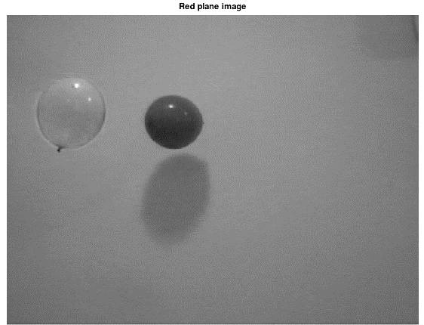

**Figure-5 Red plane image**

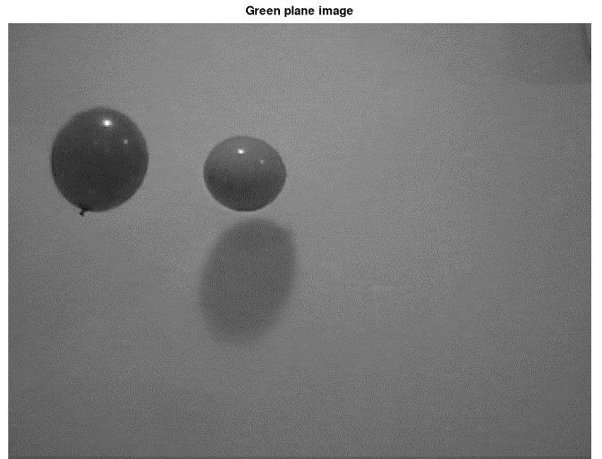

**Figure-6 Green Plane image**

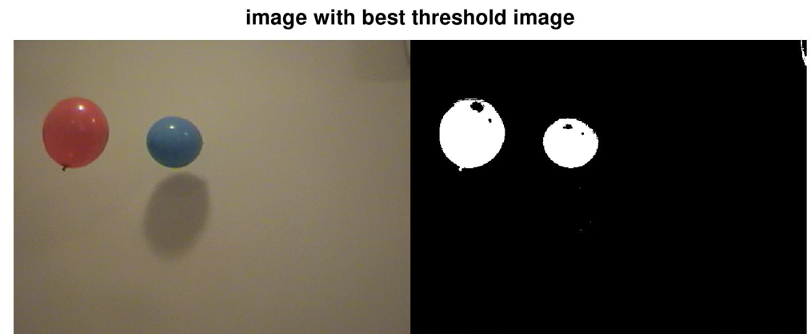

**Figure-7 Image with best double threshold**

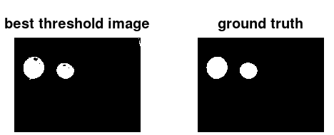

**Figure-8 Ground truth with best threshold**

**ROC (Receiver Operating Characteristic Curve) of double threshold:**

An **ROC curve** (**receiver operating characteristic curve**) is a graph showing the performance of a classification model at all classification thresholds

ROC curve plots TPR vs. FPR at different classification thresholds. Lowering the classification threshold classifies more items as positive, thus increasing both False Positives and True Positives. The following figure shows a typical ROC curve.[]

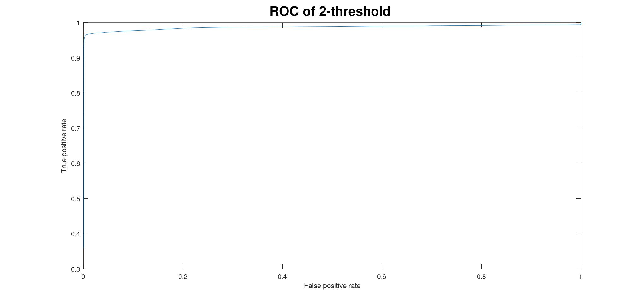

**Figure-9 ROC of Double threshold**

By observing the ROC of binary image obtained by using of two different thresholds can give more accurate binary image than compare to single threshold image since the loss of information is very less.

ROC of the Double threshold value will create a good image near to ground truth,

**COMPARATION OF SNGLE AND DOUBLE THRESHOLDS:**

|  |  |  |
| --- | --- | --- |
|  | SINGLE THRESHOLD | DOUBLE THRESHOLD |
| Accuracy | 0.9851 | 0.9964 |
| Index of Image | 91 | 93, 85 |

**Table-1 Values of Single threshold and Double thresholds**

For better comparison of both the threshold value’s by observing ROCs below.

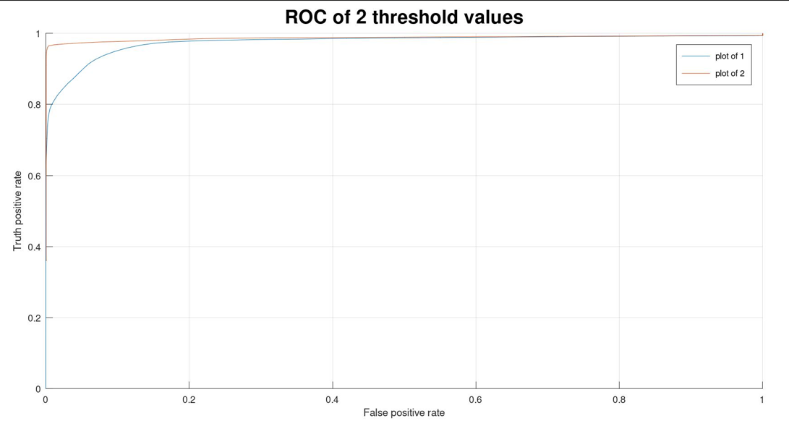

**Figure-10 ROC of both level of thresholds**

**TASK-3: What is the use of HSV (3-dimensional) image and find their threshold values**.

1.Now form both the tasks we are able to convert colour image into binary image but for this same task can be done by using HSV planes. We use Hue and saturation planes and by the same method that is used to find the two thresholds of image.

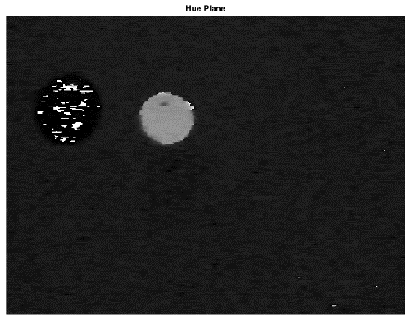

**Figure-11 Hue Plane Image**

2.Hue plane image will give the best foreground and saturation will give good background classification Now by knowing the threshold we perform OR logical operation between both the plans of the image.

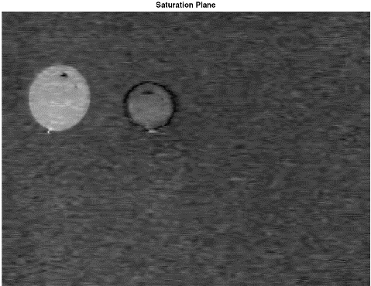

**Figure-12 Saturation Plane Image**

3.This method will provide some better accurate binary image with comparing with ground truth image. It helps in creating of mask for the region of Interest. As show in below image.



**Figure-13 Binary image formed by using HSV**

**TASK-4 Count the number of balloons present in all the images of the data set of 51 images.**

1.It is a interesting task which is counting of number of balloons. This task can be we need to understand previous tasks.

2.Considering the data set which is with 51 images of different intensity and different number of balloons.

3.To find the number of balloons from picture we need to convert image which is colour into HSV formatted image

4.Taking H-plane and S-plane by using that threshold values from which the image can be converted into binary image which is means it is a image which is with Black and White colour of 0 and 1(255).

5.Now considering that masked image is of colour white and background as black image.

6.By using some morphological operation we try to remove that unwanted noise which means some random white colour at some other places of the image to make that image which is in binary form can make it near the ground truth. So that image there will be get masked.

7.Now by using bwconncomp() which is a command in octave will help in getting of the number of region of interests present in each image.

8.By the above command we create a structure which stores the number of objects by getting that data by using ‘.’ Accessing method of structure.

9. Then trying to display the count of balloons as the title of the image as shown in the below figures

10. As we can observed that in first image no balloons, one balloon, two balloons and three balloons respectively as show in below figures.

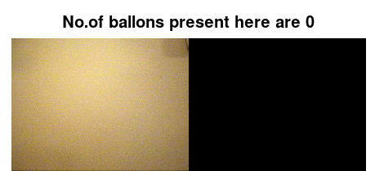

**Figure-14 No Balloon Image**

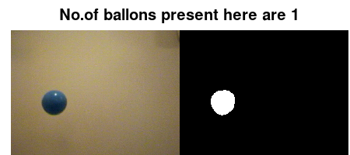

**Figure-15 One Balloon Image**

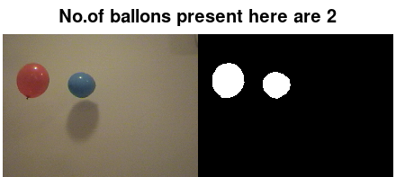

**Figure 16 Two Balloons Image**

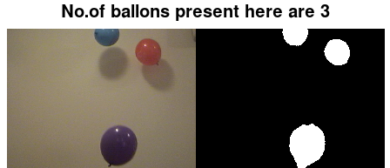

**Figure 17 Three Balloons 1**

**CHAPTER 4**

**IMPLEMENTATION AND RESULT**

**RESULT:**

As the result of this problem statements, we can consider as the confusion matrix’s Which helps to Identify efficiency of the algorithm. As we can observe in below figure

In to it have 51 images details of number of balloons in them and by true class we are able to Identify the efficiency.

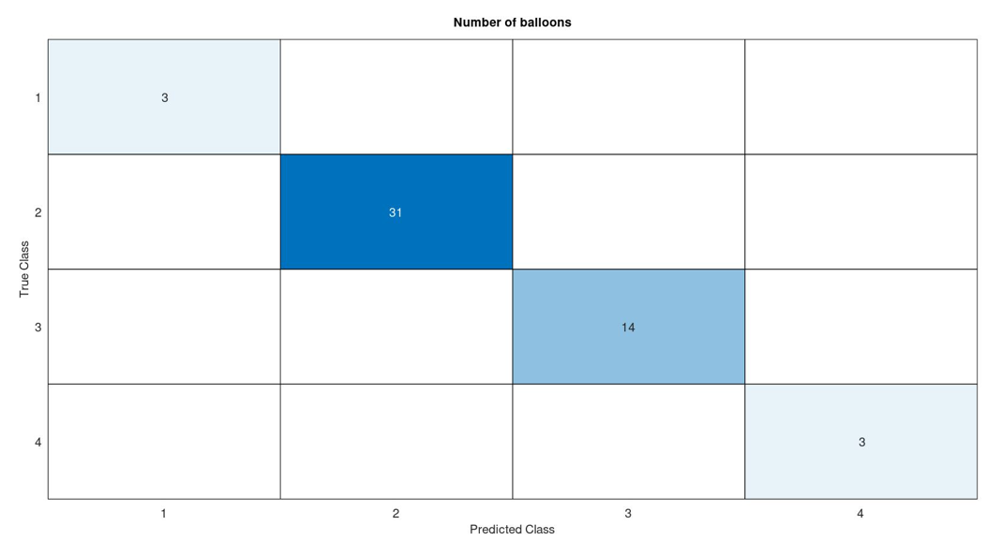

**Figure-18 Confusion Matrix**

**CHAPTER 5**

**APPLICATIONS AND ADVANTAGES**

**APPICATIONS OF IMAGE PROCESSING:**

1. Medical Imaging: Image processing is used to improve the quality of medical images, such as X-rays, MRIs and CT scans. This can help doctors to diagnose diseases more accurately.
2. Security Surveillance: Image processing is used to develop facial recognition systems and other security surveillance technologies.
3. Remote Sensing: Image processing is used to analyse satellite images and aerial photographs. This can be used to monitor deforestation, track the movement of glaciers and assess the damage caused by natural disasters.

**ADVANTAGES OF IMAGE PROCESSING:**

Image processing have various applications and numerous advantages like to improve the quality of image. To increase the use case of images not only for studying but also applying in real life and able to work in difficult areas at which mankind is unable to process them self and it made a good raise in technology.

Even if we consider Image processing a career. It a good decision since at present scenario image processing is required in all domain and if we include Machine Learning models to the system it makes the system more efficient and real time usable.

**CODES:**

**Task-1**:

clc;

pkg load image

load p44.mat

load ground_truth_p44.mat

gimg=rgb2gray(img);

timg=[];

thresh = 1:1:254;

for k= 1:length(thresh)

disp(k)

I_bin{k} = gimg < thresh(k);

[accu{k},Tprate{k},Fprate{k}] = Accurate(I_bin{k},A);

endfor

Accura=cell2mat(accu);

best_valu = max(Accura);

best_img = find(Accura == max(Accura));

figure

imshowpair(img,I_bin{best_img},'montage');

title("Image with best threshold image",'FontSize',20);

figure

imshowpair(A,I_bin{best_img},'montage');

title("Ground truth with best threshold image",'FontSize',20);

figure

plot(fp_rate,tp_rate)

xlabel('False positive rate');

ylabel('True postivie rate');

title("ROC of 1 threshold",'FontSize',20);

**Task-2:**

clc

clearvars

close all

pkg load image

load p44.mat

load ground_truth_p44.mat

r=img(:,:,1);

g=img(:,:,2);

t1 = 1:1:254;

t2 = 1:1:254;

tic;

for i = 1:length(t1)

disp(i);

for j = 1:length(t2)

I_bin1{i,j} = (r < t1(i)) | (g< t2(j));

[Accu{i,j},TPrate{i,j},FPrate{i,j}] = Accurate(I_bin1{i,j},A);

endfor

endfor

time1 = toc;

b = cell2mat(Accu);

best_red = max(b,[],2);

best_green= max(b,[],1);

best_red_Acc = max(best_red)

best_green_Acc = max(best_green)

best_red_img = find(best_red == max(best_red))

best_green_img = find(best_green == max(best_green))

f_r=cell2mat(FPrate);

t_r=cell2mat(TPrate);

se=strel('line',20,0);

out_img_2=imclose(imopen(I_bin1{best_red_img,best_green_img},se),se);

figure

subplot(1,2,1);

imshow(I_bin1{best_red_img,best_green_img})

title("best threshold image",'FontSize',20);

subplot(1,2,2);

imshow(A)

title("ground truth",'FontSize',20);

figure

%plot(f_r(best_red_img(1,:)),t_r(best_red_img(1,:)));

plot(f_r(best_red_img(1),:),t_r(best_red_img(1),:));

xlabel("False rate");

ylabel("Truth rate");

title("The plot of 2threshold values",'FontSize',20);

figure

imshow(out_img_2);

**Task-3:**

clc;

clearvars;

load p44.mat;

A=rgb2hsv(img);

a=A(:,:,1);

b=A(:,:,2);

t1=1:1:480

t2=1:1:640

I_bin2=zeros(480,640);

for i=1:length(t1)

for j=1:length(t2)

I_bin2(i,j)=(a(i,j)>0.2) |(b(i,j)>0.48);

endfor

endfor

se=strel('disk',9,0);

o_img=imopen(imclose(I_bin2,se),se);

img_out=bwareaopen(o_img,50,4);

cc=bwconncomp(img_out,4);

t=cc.NumObjects;

figure

imshowpair(img,img_out,'montage');

title(["No.of ballons present here are ",num2str(t)],'FontSize',20);

**Part-B**

**Antenna Designing**

# CHAPTER 1

**Antenna**

# PART B

**INTRODUCTION TO ANTENNA**

An antenna is a device used to transmit and receive electromagnetic signals. It is typically composed of metal elements that are designed to radiate or receive electromagnetic waves.

Antennas are used in various applications such as communication systems, radar systems, and wireless networks.

They play a crucial role in enabling the transmission and reception of signals over long distances. The design and characteristics of an antenna determine its efficiency and performance.

### Different Types of Antennas

Till now we have covered the properties of antennas, and now we will discuss different types of antennas that are used for different applications.

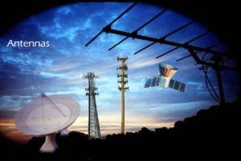

Types of Antennas

* Log Periodic Antennas
* Wire Antennas
* Travelling Wave Antennas
* Microwave Antennas
* Reflector Antennas